**FISHER HALL**

**WELCOME WEEKEND BOOKLET**

**2021-2022**

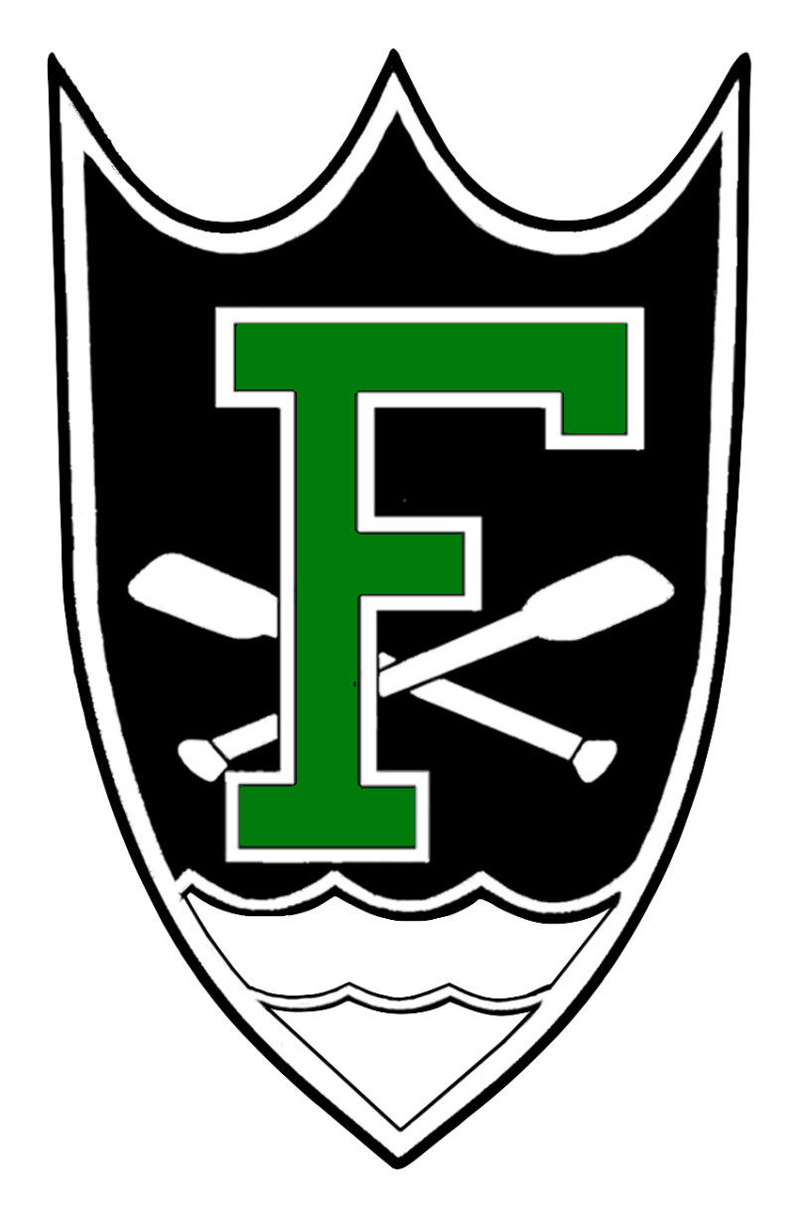

*Table of Contents*

From the Desk of the Welcome Weekend Captains

Meet the Staff: Joey

Meet the Staff: AR’s and RA’s

Meet Hall Government

Meet the Captains

Meet the Ambassadors

Rooms

Ellie’s Deli

Brother and Sister Halls: Carroll and J Fam

Service

Athletics

Events: Fisher Funk

Events: Fisher Regatta

ND Jargon Dictionary

Nearby Stores/Restaurants

Useful Websites

# From the Desk of the Welcome Weekend Captains

Welcome New Fishermen!

As Welcome Weekend Captains, we are happy to be in charge of your introduction to the family of Notre Dame, and of Fisher Hall. Here at the Cadillac of Dorms, we boast a long history of excellence in academics, athletics, and service. But more than anything, we are proud of our unyielding sense of community as we live out our motto that “all are welcome in this place.”

Regardless of your background or your story, you belong at Notre Dame, and you especially belong in Fisher Hall. Our job as Welcome Weekend Captains is to show you all that the University and the hall has to offer, and invite you into a something that is more like family than friendship.

With our rector, hall staff, hall government, and the Fisher community at large, one thing is true: we work hard together and we play hard together. As the most accomplished group of first-years to enter Fisher, we are sure that you will play an integral role in continuing the legacy of Fisher as the greatest hall on campus.

We all feel that Fisher Hall is a special place of good work and good fun, of friendship and family. We cannot wait for you to begin your time here, starting with an experience that you will never forget: Welcome Weekend.

Welcome home,

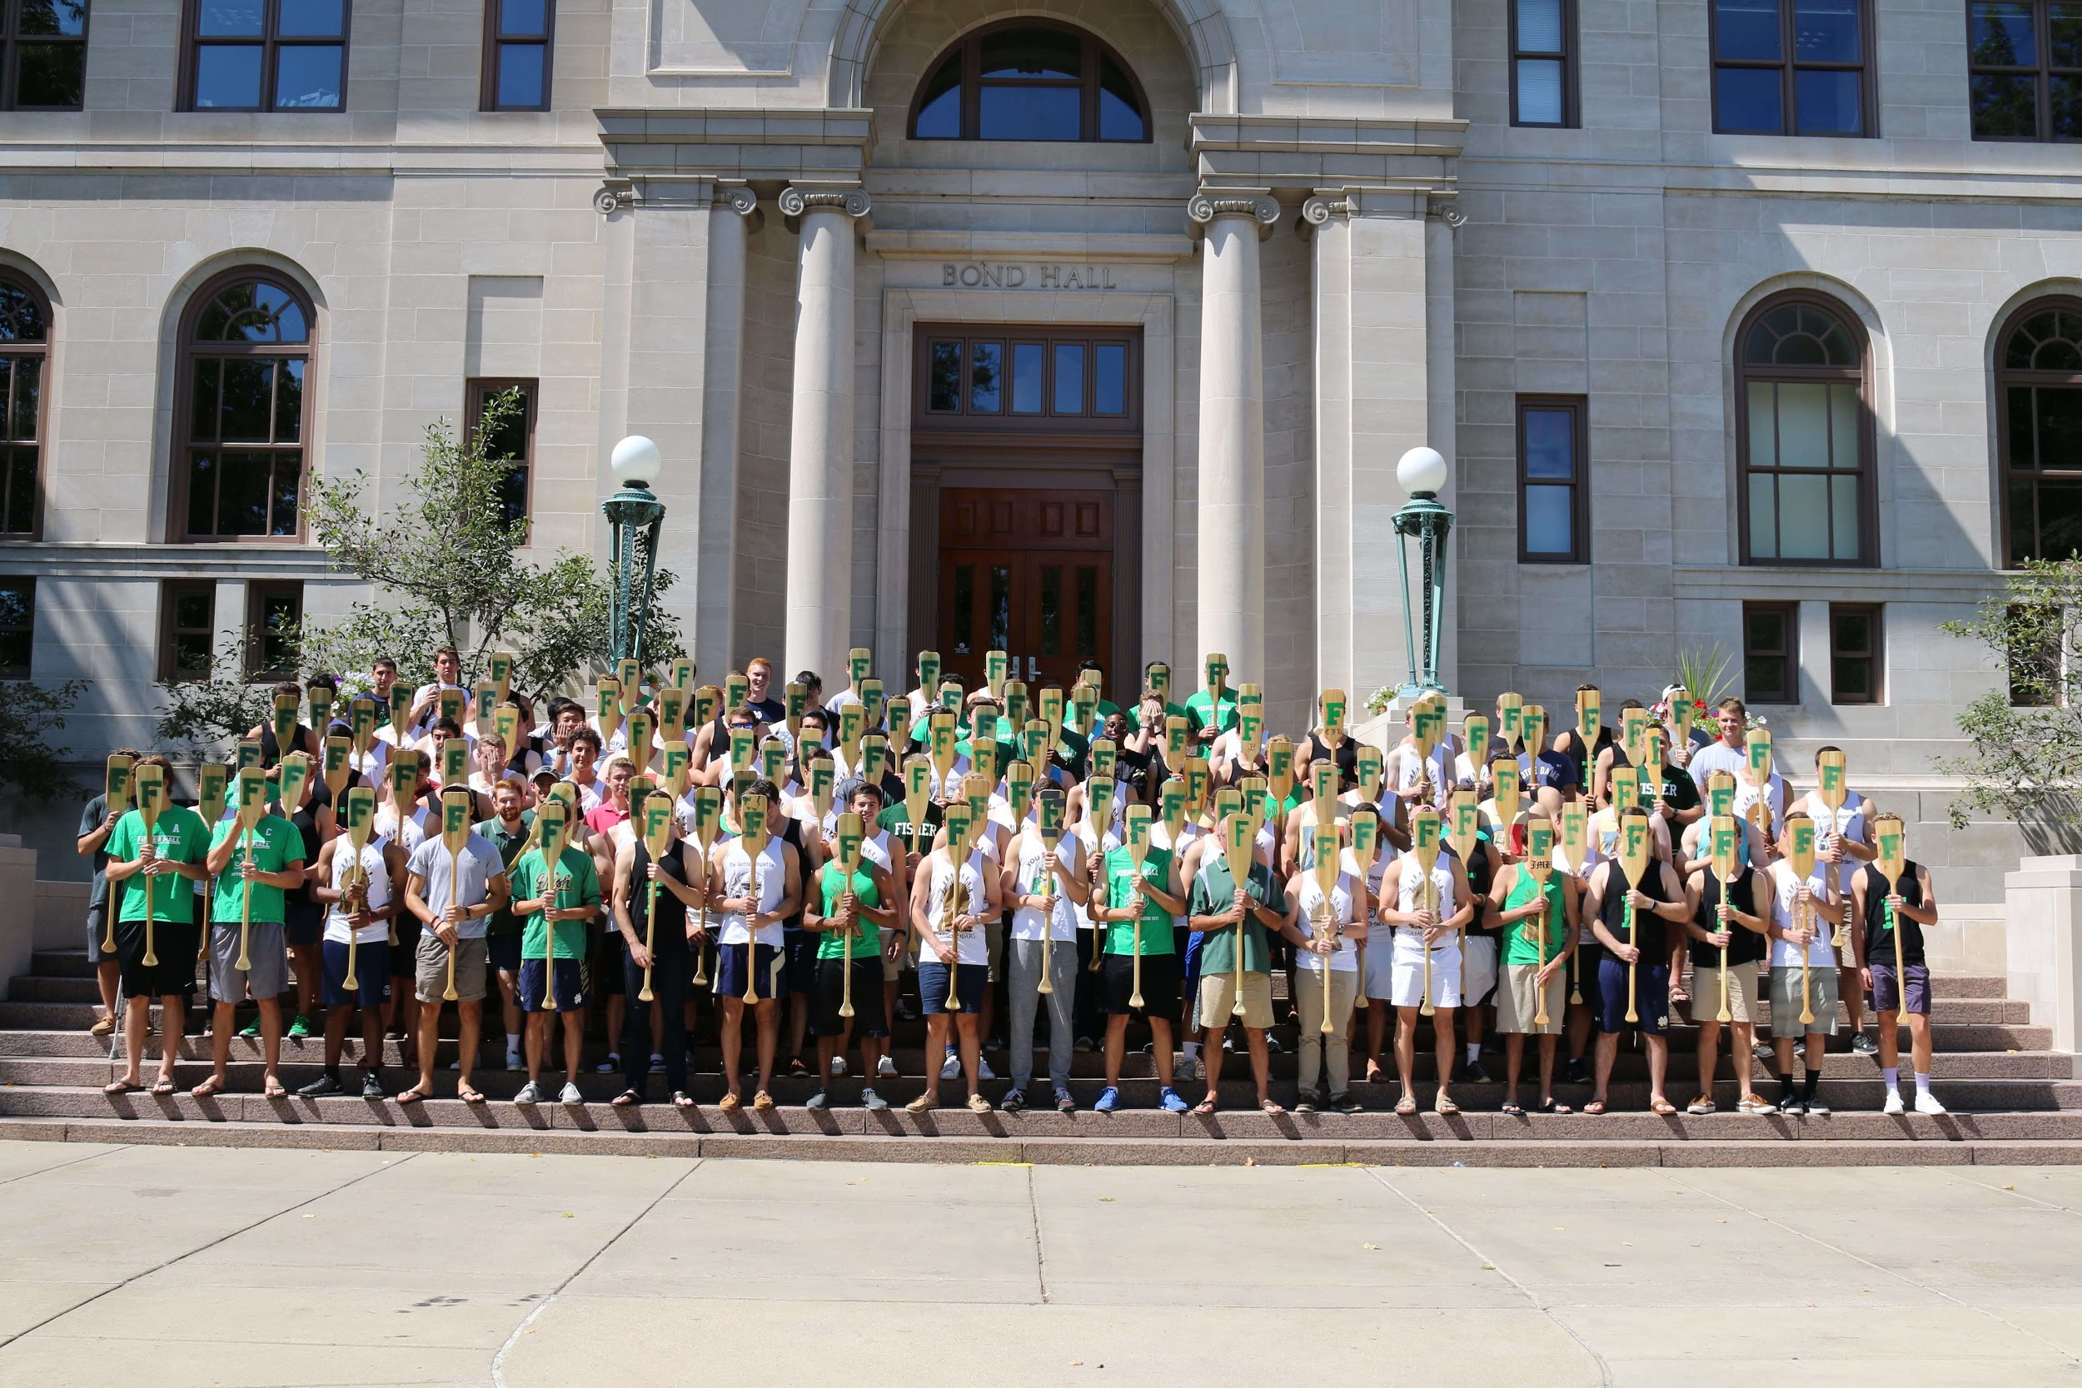Alex and Niels

# Meet the Staff: Joey Quinones - Rector

Joey Quinones is a Southern California (San Dimas) native, having graduated from Notre Dame in 2018 with a Bachelor’s degree in Mechanical Engineering with a Minor in Theology, serving as an RA of Keough Hall and captain of the Men’s Boxing Club. He completed his Masters in Education in 2020 through the ACE program, having taught 5th grade Math, Science, Social Studies, and Religion in Tulsa, OK for two years at St. Pius X Catholic School. This past year he served as an Assistant Rector of Baumer Hall while concurrently completing his Masters in Engineering, Science, and Technology Entrepreneurship through the ESTEEM program. It is through these experiences that he appreciates and is constantly impressed by the development of the person and finds his calling in seeing, learning, knowing, and working to bolster humanity through the emboldening of the dignity of each person. Joey enjoys ice cream, obstacle course races, unorthodox fitness programs, and The Masked Singer.

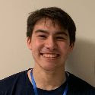

When asked why he wanted to serve as Rector, Joey answered: “I have been formed by the residence hall community of Notre Dame and I am so excited to continue the traditions of community with the men of Fisher Hall as they grow into themselves during their time here. I eagerly await welcoming and welcoming back all of my residents as we tackle another year unlike any other together!”

# Meet the Staff: AR’s and RA’s

AR = Assistant Rector, RA = Resident Assistant

A Section = Rooms X01-X21, B Section = Rooms X26-X41

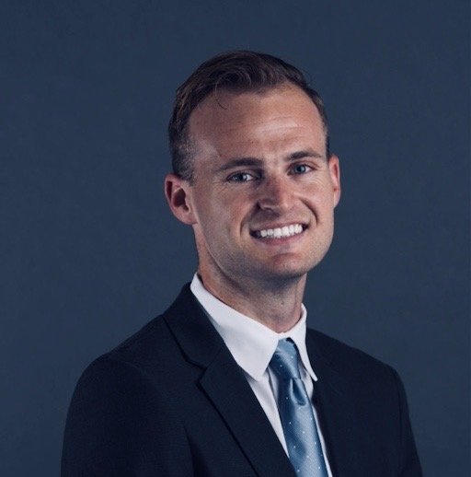

**Name**: Jake Landreth

**Hometown:** Los Angeles, CA

**Major:** Law

**Hobbies/Interests:** Tennis, running, a good cider beer

**Fisher Section:** 4th Floor AR

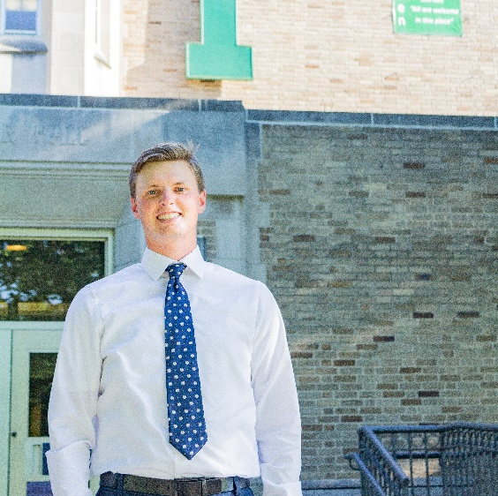

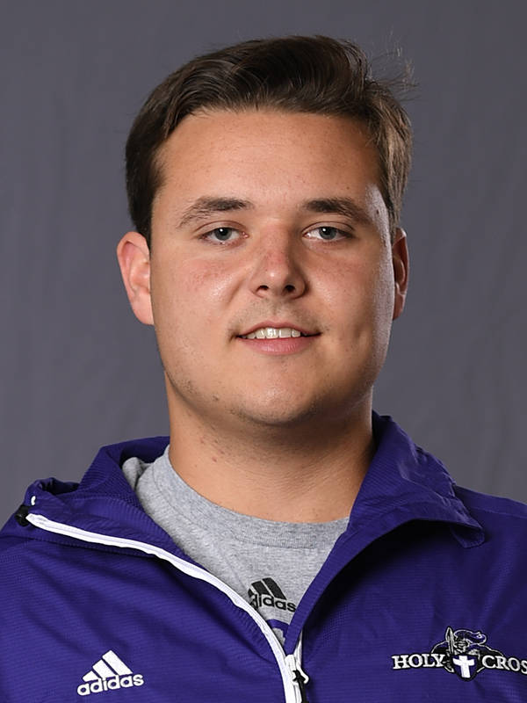

**Name**: Hunter Reh

**Hometown:** San Diego, CA

**Major:** M.S. Management

**Hobbies/Interests:** Golf, technology, drones

**Fisher Section:** 3rd Floor AR

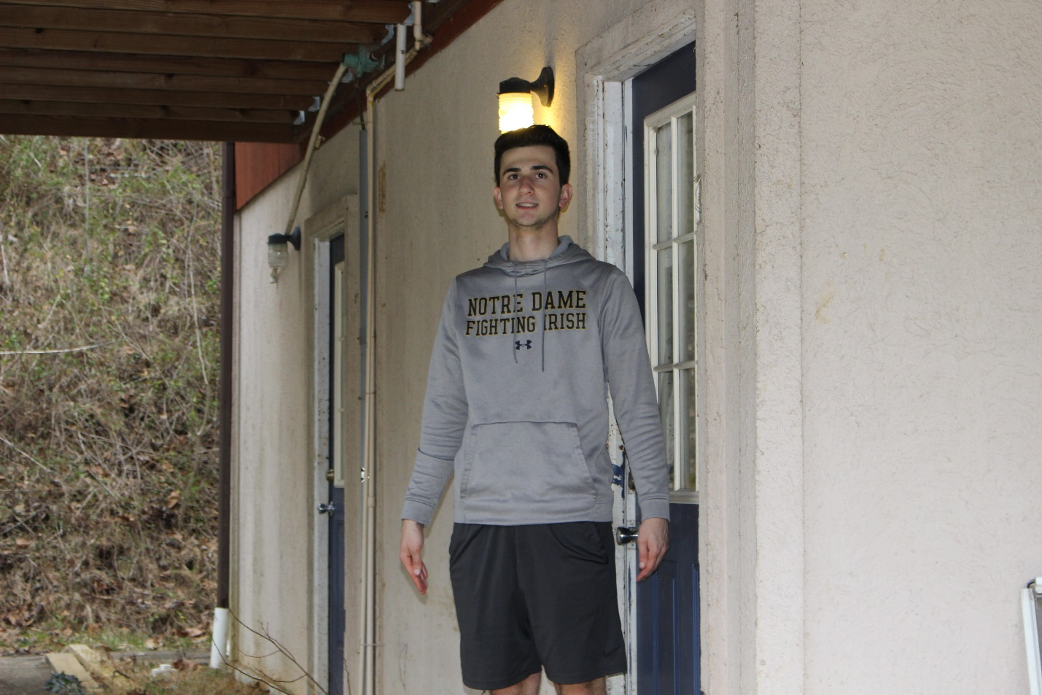

**Name:** Peter (Pete) Kalemkerian

**Hometown:** Ann Arbor, MI

**Major**: Finance

**Hobbies/Interests:** The 4-time Super Bowl Champion New York Football Giants, Eli Manning, Danny Dimes, Cracker Barrel, Arby's, using offline spTMS & rTMS in an attempt to activate latent working memories

**Fisher Section:** Basement RA

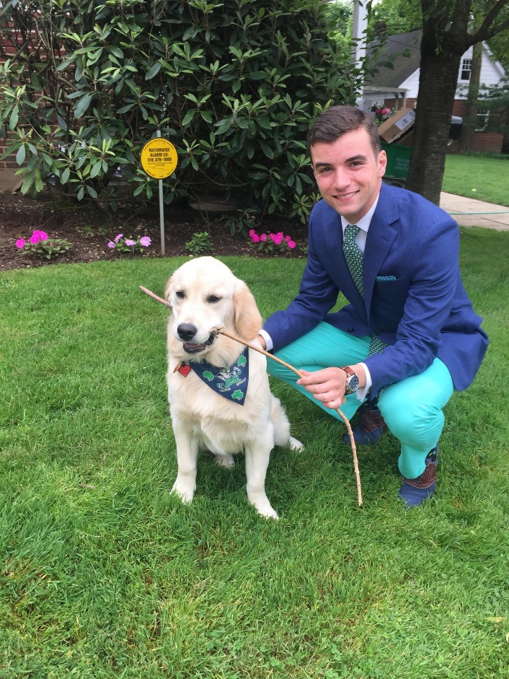

**Name:** Chris Mercadante

**Hometown:** Garden City, NY

**Major:** Economics and Spanish

**Hobbies/Interests:** Slapping my hands on my pants when the ice cream store is closed, Catalonian Revolutionaries, Supply, Demand, Soccer

**Fisher Section:** 1st Floor RA

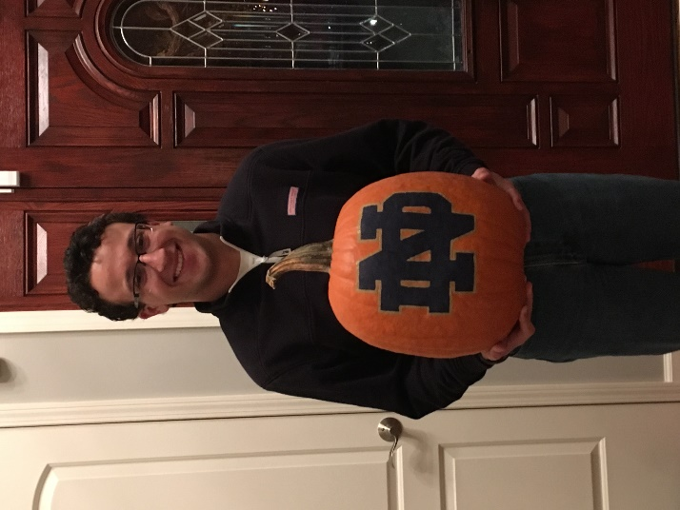**Name:** Andrew Marquardt

**Hometown:** Western Springs, IL

**Major:** Chemical Engineering

**Hobbies/Interests:** I play guitar, teach religious ed, run, play basketball, hike (sometimes), love Chicago sports except the Cubs, and will talk your ear off about my research if you give me the chance, so unless you like chemistry, don't..., Oh and I oppose the New York Football Giants

**Fisher Section:** 2nd Floor RA

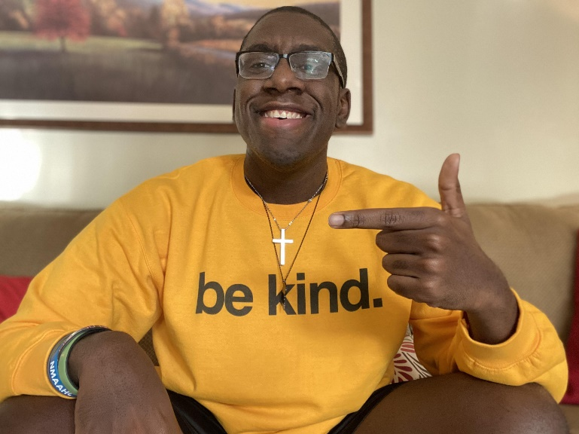

**Name:** Tarik Brown

**Hometown:** Jacksonville, FL

**Major:** Computer Science

**Hobbies/Interests:** Jazz Music, Anime, Video Games, Working Out

**Fisher Section:** 3rd Floor RA

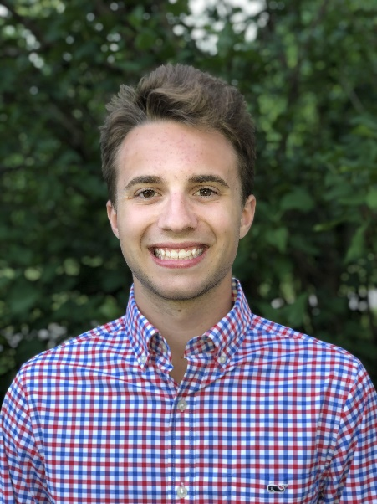

**Name:** Isaiah Metcalf

**Hometown:** North Webster, IN

**Major:** Neuroscience and Behavior (Pre-Med)

**Hobbies/Interests:** Swimming, Pour-Over Coffee, Waterskiing, and the Brain

**Fisher Section:** 4th Floor RA

# Meet the Staff: Priest in Residence

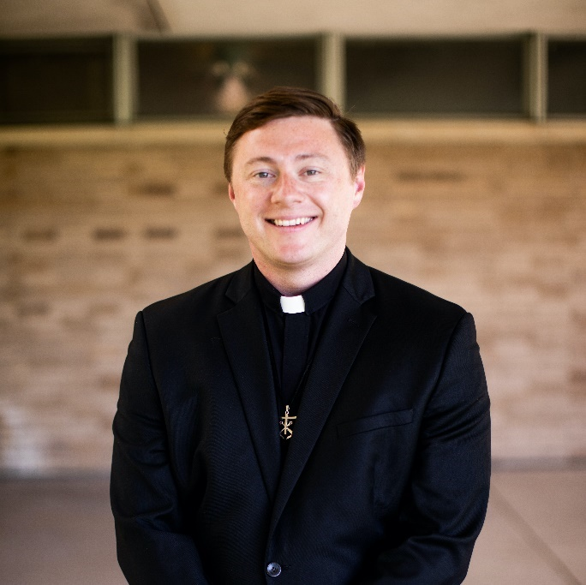

**Name:** Fr. Brendan McAleer, C.S.C.

**Hometown:** Arlington Heights, IL

**Hobbies/Interests:** "Making God Known, Loved, and Served"

**Fisher Section:** 3rd Floor

# A person lying on a couch with dogs on the back Description automatically generated with low confidenceMeet Hall Government

**Name:** Henry Cella

**Hometown:** Geneva, IL

**Major:** Finance and Philosophy

**Hobbies/Interests:** running, peaking in high school, eating peanut butter, quoting obscure comedians

**Fisher Section:** 1B

**Role:** President

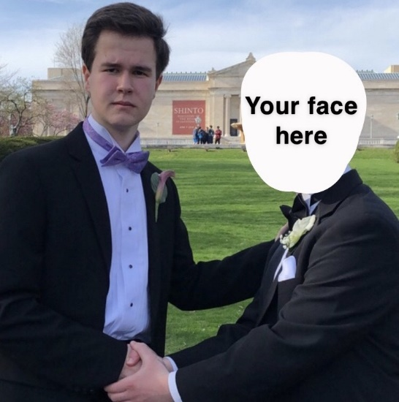**Name:** Danny Brennan

**Hometown:** Cleveland, OH

**Major:** History and Theology

**Hobbies/Interests:** Cleveland and its suburbs, the renewal of Major General Joseph Hooker’s legacy despite the defeat at the Battle of Chancellorsville, watching Matt Ellingson eat Pizza Rolls

**Fisher Section:** 1B

**Role:** Vice President (Fall)

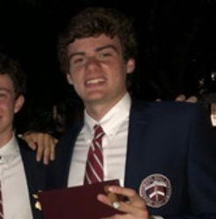

**Name:** Graham Ragsdale

**Hometown:** Nashville, TN

**Major:** Political Science

**Hobbies/Interests:** Fisher B team basketball, Orbeez, golf, wedding crashing, the home of one dollar Busch Lights

**Fisher Section:** 1B

**Role:** Vice President (Spring)

# Meet the Captains

These juniors will be leading Fisher’s Welcome Weekend!

Feel free to email us with any questions, or just to say hello!

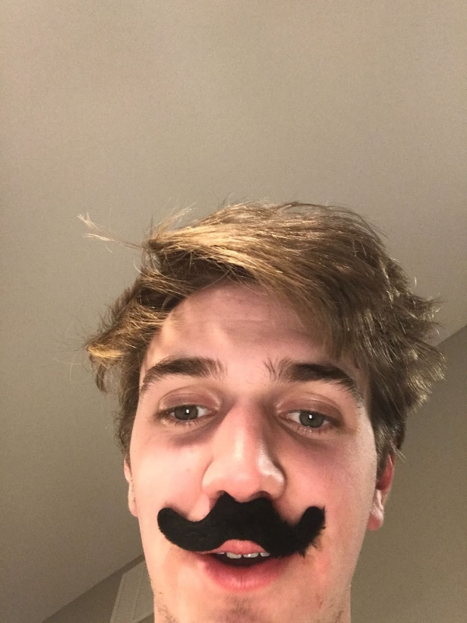

**Name:** Niels “Dunks” Caspersen

**Hometown:** Indianapolis, IN

**Major:** Finance and Philosophy

**Hobbies/Interests:** Triremes, very small rocks, the tuatara, guys named Lawrence, skee-ball

**Fisher Section:** 3A

**Email:** Ncaspers@nd.edu

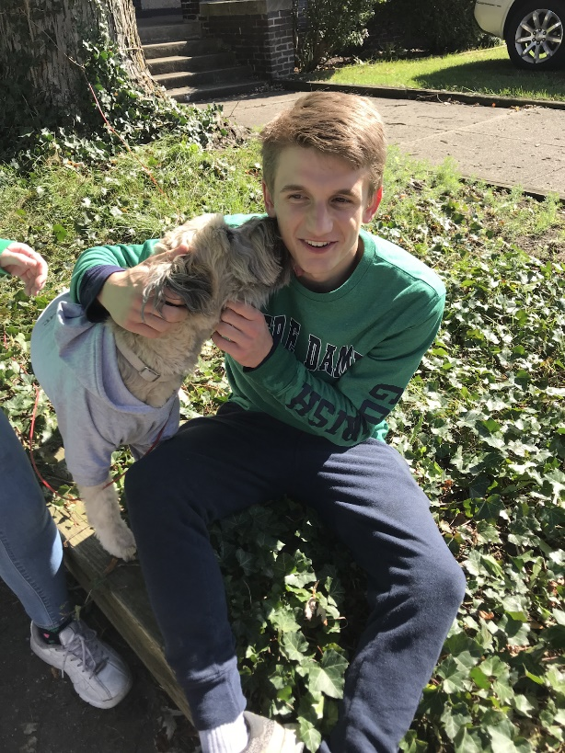

**Name:** Alex “Barlos” Taylor

**Hometown:** Doylestown, PA

**Major:** Finance

**Hobbies/Interest:** Traveling, terraforming Venus, the third shower in 3A, uncrustables, Mazz snacks

**Fisher Section:** 3A

**Email:** Ataylo24@nd.edu

# Meet the Ambassadors

These sophomores will be aiding Fisher’s Welcome Weekend!

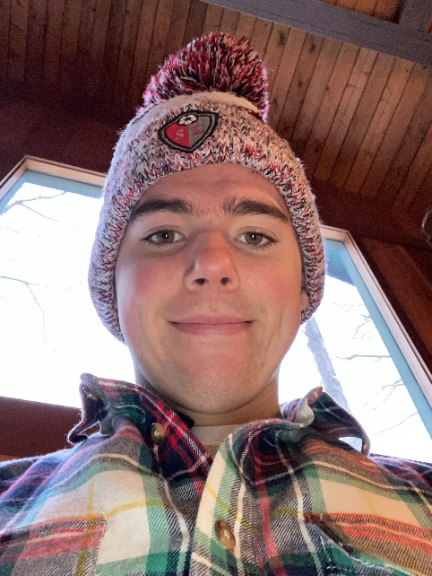

**Name:** Clayton “X Æ A-Xii (Kyle)” Glasgow

**Hometown:** Spring Lake, MI

**Major:** Environmental Science

**Hobbies/Interest:** Running, racing snakes, 19th century Italian opera, big leaves, small forks

**Fisher Section:** 1A

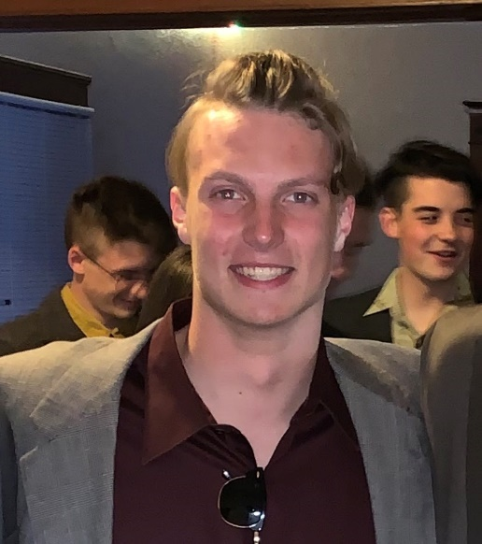

**Name:** Ethan “Father Tim Crouton” Hoying

**Hometown:** Powell, OH

**Major:** Mechanical Engineering

**Hobbies/Interest:** Disc golf, trebuchets, digging holes, Pokemon Go

**Fisher Section:** 2A

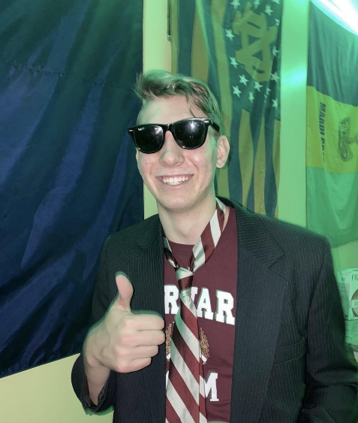

**Name:** John “Flounder” Knapke

**Hometown:** Fort Recovery, OH

**Major:** Finance

**Hobbies/Interest:** Playing bad golf, wasting my height, finánce, Mario Kart enthusiast, basement culture

**Fisher Section:** Basement

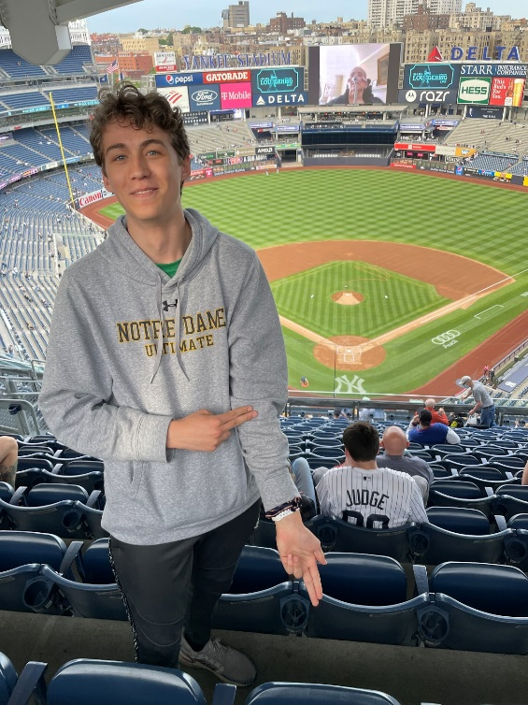

**Name:** Connor “Lugnut” Tinson

**Hometown:** Bronxville, NY

**Major:** Architecture

**Hobbies/Interest:** Ultimate frisbee, ambulance rides, REM cycles

**Fisher Section:** 3B

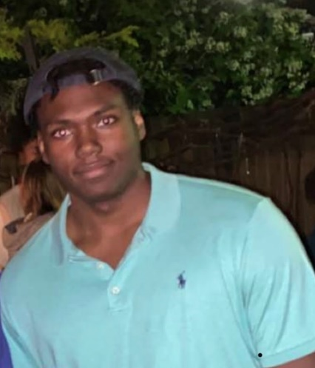**Name:** George “Ginobes” Roby

**Hometown:** Saint Louis, MO

**Major:** Marketing and Political Science

**Hobbies/Interest:** Levitating by Dua Lipa ft. Dababy, playing a poor game of golf, having a strange connection to a shocking amount of people

**Fisher Section:** 2A

# Rooms

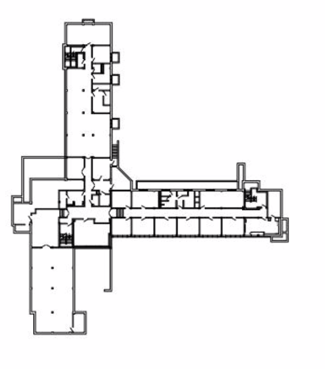

In Fisher Hall, First Years live in doubles with two closets and a sink, as well as modular furniture. This modular furniture consists of two beds, two wardrobes, and two desks, which are able to fit together in a variety of ways, including lofting and bunking. A typical arrangement can be seen in the images below.

Chapel

A Section

B Section

Additionally, each section has its own bathroom and shower room, and each floor has its own lounge and study room, with other study spaces on the first and basement floors.

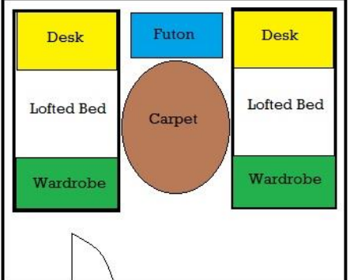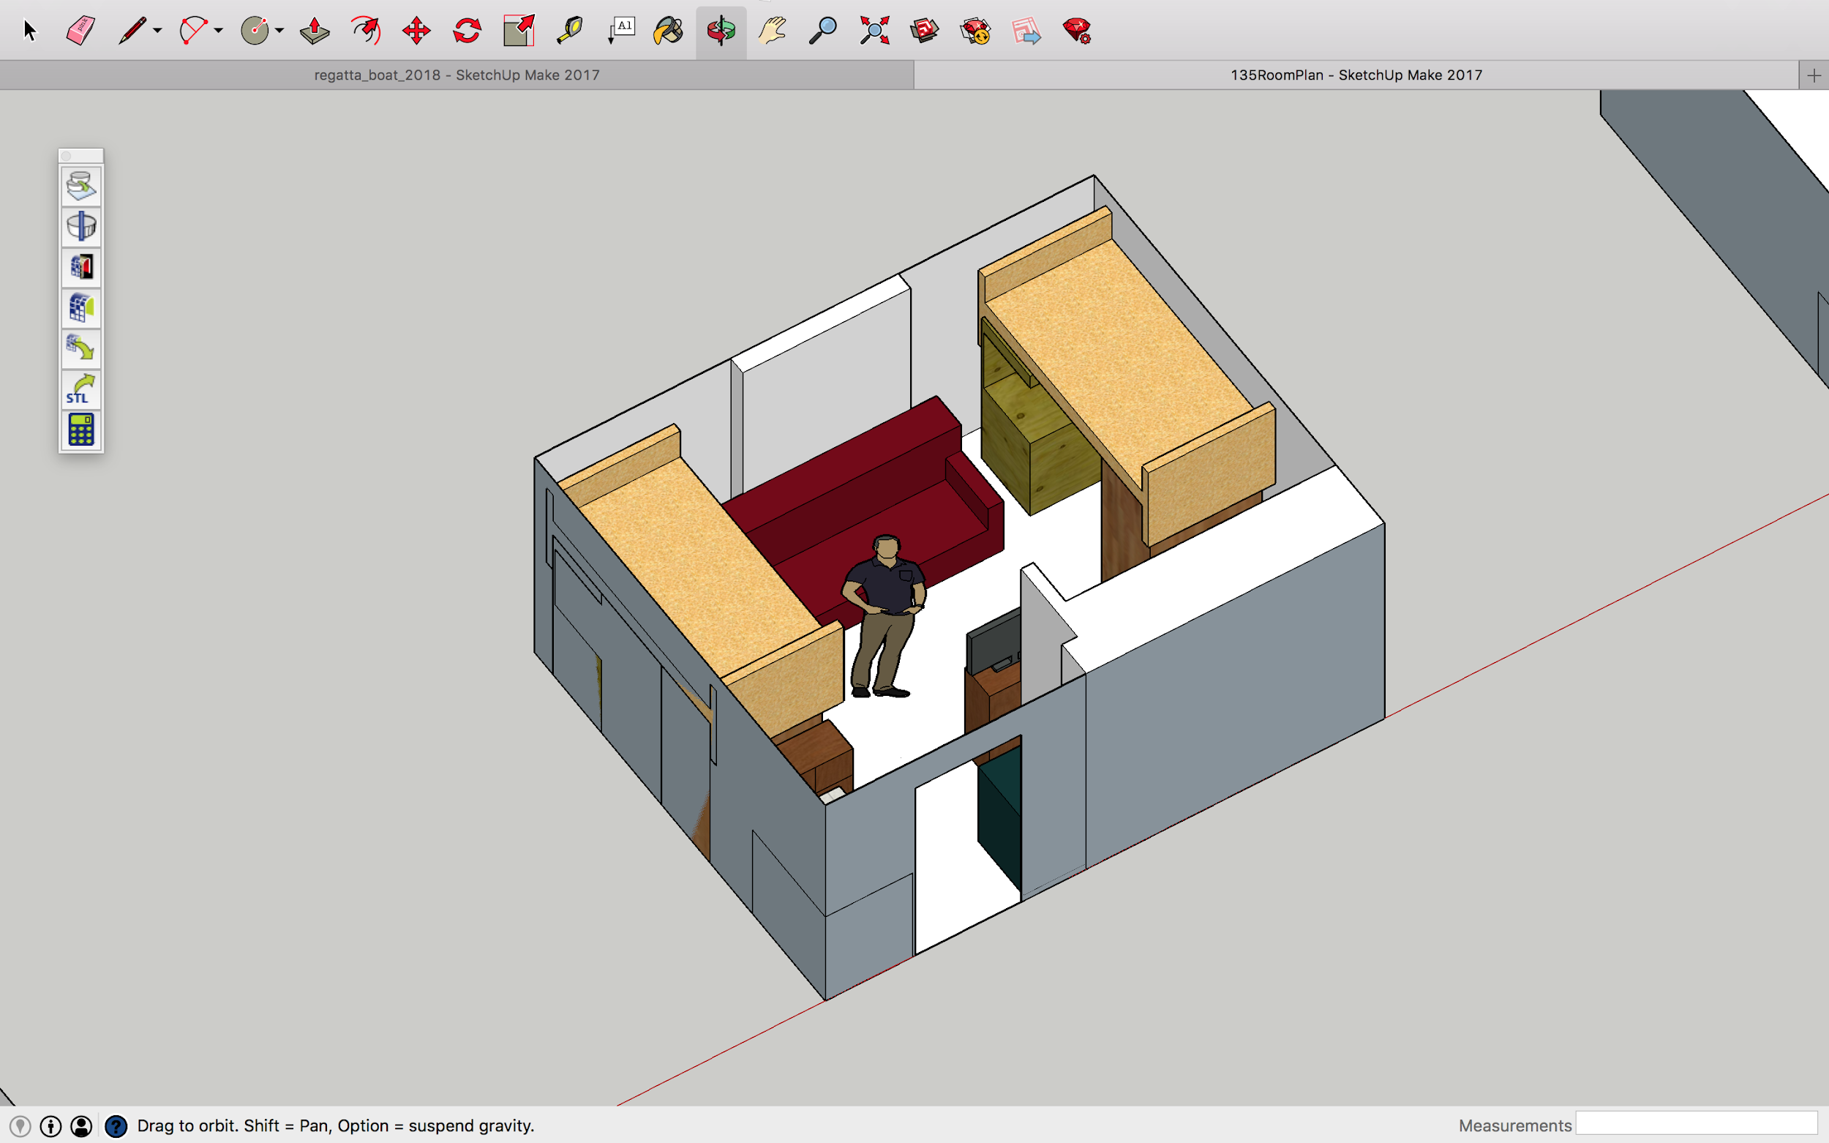

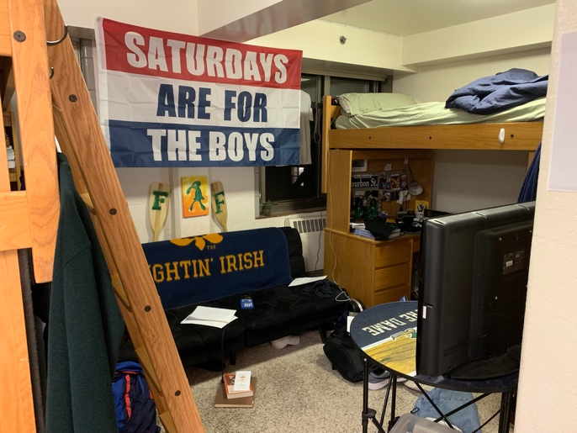*A typical arrangement in a double.*

*Amenities and Shared Spaces*

The Cadillac provides all the necessary amenities to ensure a healthy, happy, and comfortable lifestyle during your years here. Listed below are some of our fine offerings.

* **Billiards Room** – An air-conditioned 24-hour lounge (i.e. parietals do not apply to this space) in the basement complete with couches, flatscreen TV’s, a billiards table, a ping pong table, and Ellie’s Deli
* **Ellie’s Deli** – see page 22
* **Fred and Sally Room** – another of Fisher’s 24-hour lounges by the front door
* **Chapel** – The Chapel of St. Joseph hosts mass every Monday-Wednesday and Sunday at 10pm
* **Fisher Gym** – Fisher’s in-house gym complete with a squat rack, pull up bar, scale, bench press, treadmill, stationary bikes, punching bag, and dumbells
* **Laundry Room** – 6 washers, 12 dryers, an ironing station, a folding station, and a detergent vending machine
* **Study Rooms** – Fisher has a large rooms of study carrels and a reading room (“The Pit”) in the basement and a study room on each floor
* **Vending Machines** – proving all the soft drinks and snacks Fishermen desire
* **Fisher Kitchen** – a complete kitchen with cookware and some basic ingredients
* **Elevator** – Fisher is handicap accessible except for the basement rooms
* **Microwave** – shared microwaves in the basement and on the third floor
* **Section Restrooms** – each section has a men’s restroom
* **Private Restrooms** – private restroom for anyone especially non-male guests accessible through the Billiards Room or the Fred and Sally
* **Section Showers** – four individual showers
* **Cleaning and Maintenance** – Fisher is professionally cleaned and maintained regularly. Be sure to say hi to Saida, who helps keep Fisher clean!

*Packing*

While nothing can quite prepare you for Fisher’s greatness, a few essential supplies might help. Know that this list is just suggestions for informational purposes and in no way requirements.

**Good to have:**

* **Bedding** – residents bring their own sheets. Fisher beds are size twin extra-long. A mattress and frame are provided as well as a sideboard and ladder should you choose to loft or bunk your bed.
* **Shower shoes** – as showers are shared spaces, many residents wear some sort of flip-flops to the shower.
* **Futon** – many residents like to have a comfortable place to sit. Most furniture arrangements would fit a 5’-6’ wide futon / couch.
* **Shelving** – Fisher provides a dresser with a hanging rod and a sock drawer as well as a fully shelved desk. Bring extra shelving / storage if you would like.
* **Fan** – Fisher is not air conditioned, so the first week or so can be hot.
* **Bike** – This one is a very light suggestion. About one in ten Fishermen have a bike on campus. Skateboards, scooters, and the like are allowed as well.

**Not Necessary:**

* **Iron** – irons are available in the laundry room if you ever need it.
* **Extra lighting** – each room has a ceiling light and each desk has a light built in.
* **Extra cookware** – there is cookware in the kitchen and most of the meals you’ll have will probably be from the dining hall anyway.
* **Weights** – you can find these in the Fisher gym.
* **Microwave** – not allowed by Notre Dame. You can find shared microwaves on the 3rd floor and in the basement.

*There is a Target and a Bed Bath and Beyond near campus. BB&B’s “Pack and Hold” program allows you to order beforehand and pick up in Mishawaka.*

# Ellie’s Deli

At Fisher Hall, we hold food to a very high standard. As such, we are home to Ellie’s Deli, a food service in honor of the late, great Ellie (the dog of a former rector) that still makes the finest artisan paninis on campus from secret recipes. Located in the basement lounge, Ellie’s offers world-famous grilled cheese and other handcrafted sandwiches during late-night hours at modest prices. Run by Fishermen, for Fishermen, this counter provides the succulent snack that completes any night of work or fun.

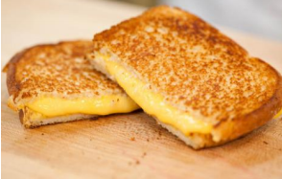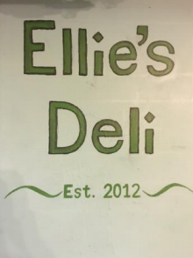

# Brother and Sister Halls: Carroll and Johnson Fam

# 

Fisher Hall is friendly with everyone on campus, but Carroll Hall and Johnson Family Hall hold a special place in our hearts as our brother and sister halls, respectively. From BBQ’s to masses to dances to signature events, we will support each other with mutual respect and community this school year. Carroll hall is located on the Saint Mary’s Lake (about a 0.4 mi walk from Fisher), and Johnson Fam Hall is located near the northeast side of campus (a 0.7 mi walk from Fisher).

You will get a chance to meet our fine brothers and sisters in a variety of events during Welcome Weekend.

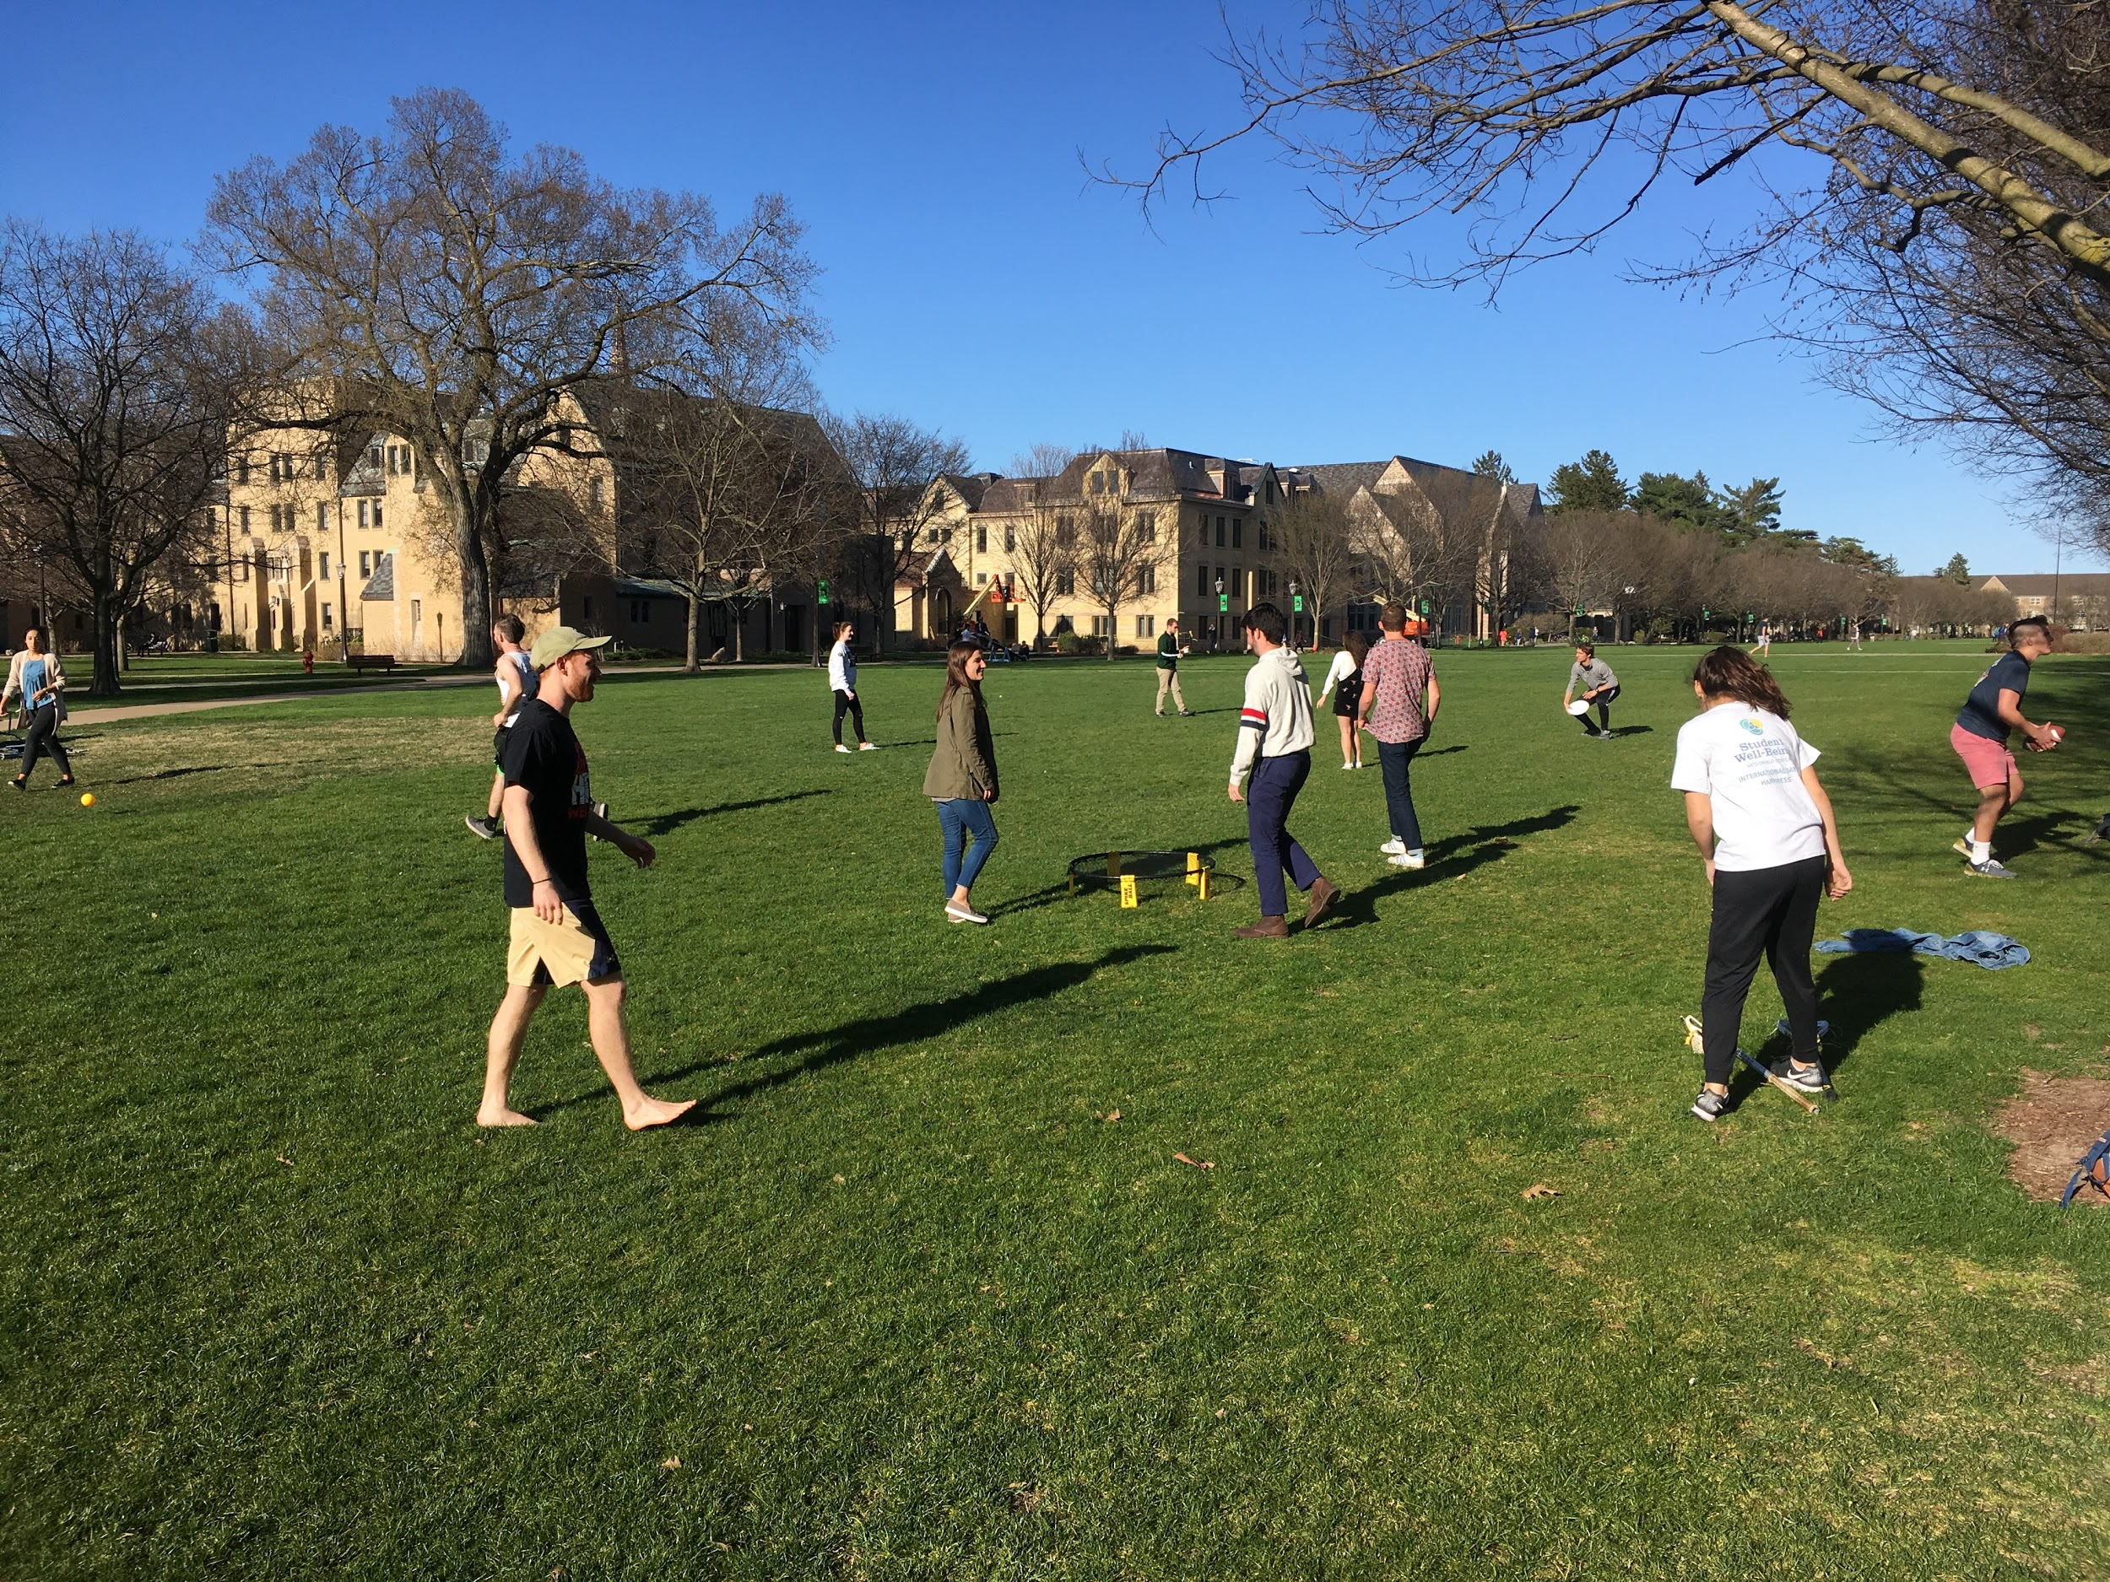

# Service

Fisher Hall is very passionate about its relationship with the community of South Bend. One of our most meaningful relationships is with St. Adalbert’s. This catholic elementary/middle school, located in a low-income area of the town, is truly near and dear to our hearts. In the past five years, through the Fisher Car Smash and the Fisher Regatta, we have donated over $40,000 to our brothers and sisters at St. Adalbert’s helping to build a new science lab, computer lab, and a fence surrounding the perimeter of their campus. Fisher’s relationship with St. A’s extends far beyond fundraising, too. Many of the men of Fisher volunteer to tutor weekly at St. Adalbert’s. We have even hosted events with the children on campus and attended events on their campus as well. During welcome weekend, you will have the opportunity to visit St. Adalbert’s during the Day of Community and see the beautiful symbiosis between these two communities first hand.

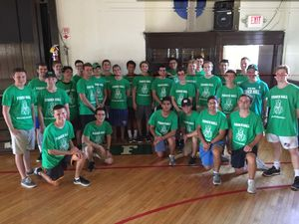

# Athletics

Fisher Hall bears a tradition of sportsmanship and competition in Inter-Hall Sports. In the past few years, we have been especially dominant in Lacrosse, Hockey, Football, Baseball, and Tennis. Fishermen can also participate in a variety of other sports through Notre Dame RecSports.

Somewhat less competitive (but not really) is *Intra-*Hall sports – short seasons where Fisher floors compete against each other for the most prized possession on the entire Notre Dame campus: *The Fisher Hall IntraHall Intramural Competitive Sports Golden-Oar Championship Super-Series Trophy*.

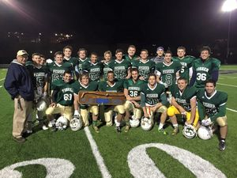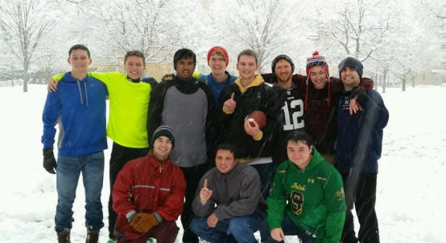

# Events: Fisher Funk

The Fisher Funk is our SYR (see jargon below), hosted in the Fall and loved/envied by everyone on campus. It is a chance to travel back in time, dress up in anything that looks remotely like it’s from the 70’s, and bowl with friends and dates. Embrace your inner hippie and just go with the flow. Mustaches and sideburns encouraged.

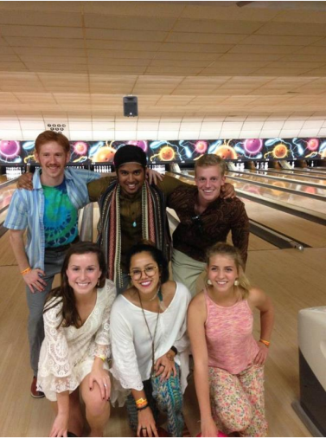

# Events: Fisher Regatta

The Fisher Regatta is our Signature Event, hosted in the Spring and considered by everyone in the world to be the greatest idea to grace the minds of men. Keenan Revue? Never heard of it. Keough Chariot Race? Never heard of it. But YA GOTTA REGATTA.

On the last Saturday of April, halls and clubs from across campus gather at St. Mary’s Lake to race against each other in hand-made boats. Fisher Hall organizes, runs, and participates in the event, all of the proceeds of which go to St. Adalbert’s. We have now made it commonplace to smash our fundraising goal with the 2021 Regatta maintaining the tradition as our efforts brought in over $21,000!!! One of the Fisher boats, Floaty McFloatFace, has won the Fisher Regatta thus earning the ceremonial Golden Oar for three years straight. Will you be next?

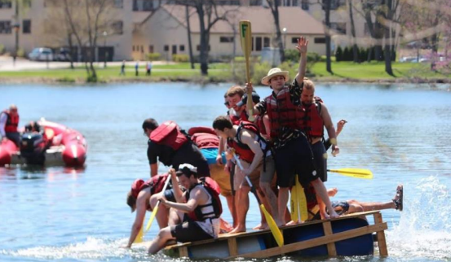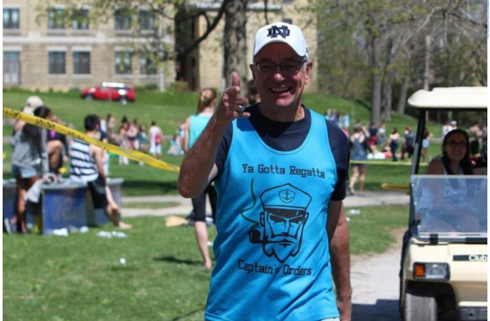

# ND Jargon Dictionary

AcoustiCafé: Performances by student musicians held every Thursday night in LaFortune Student Center

Archie: College of Architecture student, pronounced “Arkie”

Bengal Bouts: Student boxing tournament which occurs in February. All proceeds go to the Holy Cross Missions in Bangladesh.

Bookstore Basketball: Largest outdoor 5 on 5 basketball tournament in the world, held in April.

CSC: Center for Social Concerns; located by the library (Geddes Hall), the CSC is the location for information regarding service projects. Also has free coffee.

CHEG: Chemical Engineering student

Stonehenge: Peace memorial fountain located on Fieldhouse Mall (North Quad area)

CoMo: Coleman-Morse Center; On South Quad across from South Dining Hall, CoMo houses the First Year of Studies offices, Campus Ministry, the Writing Center, and a large study lounge.

DART: Old process of class registration. Replaced by NOVO.

DeBart: DeBartolo Hall; the main classroom building and is next to the stadium and Duncan Student Center

Dillon Hall Pep Rally: Dillon’s annual pep rally hosted on the Friday afternoon before the first home football game of the season and located in front of Dillon Hall on South Quad

Dome Dance: Special formal given to Hall of the Year, Men’s Hall of the Year, and Women’s Hall of the Year award winners.

Domer: Any Notre Dame student or graduate

Domer Dollars: Real money that is converted to Notre Dame-accessible funds

DPAC: The DeBartolo Performing Arts Center, located at the end of DeBartolo Quad. This giant building houses a concert hall, theater, organ hall, TV studio, and movie theater and features performances throughout the year.

DuLac: Document which lists the rules of life and conduct at Notre Dame

Duncan Student Center: Contains a variety of places to eat (Modern Market, Star Ginger, Hagerty Fam Café), as well as study spots, a rock wall, a great gym, and more

D-2: Resident student parking lot near Mod Quad

D-6: Resident student parking lot located by the Campus Security building

Fieldhouse Mall: Site of the former fieldhouse, near LaFortune Student Center and North Quad, now contains the Clarke Memorial Fountain (“Stonehenge”)

Fisher Formal: Formal dance held traditionally (for the past two years) in the Rock.

Fisher Funk: Fisher’s fall “dance”. The entire dorm dresses in 70s themed clothing and enjoys an evening of bowling and music with their dates at Chippewa Bowl.

Fisher Regatta: Hosted by Fisher Hall, the Regatta is the annual boat race held on St. Mary’s Lake during the spring semester. By far the best signature event on campus, and perhaps the world.

Flex Points: Monetary credit (1 Flex Point = $1.00) accepted at campus meal locations such as Subway and Modern Market

Grab ‘n Go: Campus meal option offered in both dining halls which provides a sack meal to students who don’t have time to eat in the dining hall. Take note: North and South Dining Hall actually offer different Grab ‘n Go options.

Holy Cross College: Liberal arts college across the street, also founded by the Congregation of Holy Cross like Saint Mary’s and Notre Dame

Huddle: Place to get food and meet friends. Located in LaFortune Student Center

insideND: Website that facilitates class registration (NOVOing) and web enrollment, and allows students to access final class grades and class schedules

JACC: Joyce Athletic and Convocation Center, acronym pronounced “Jack”. The JACC is the home to many varsity athletics, concerts, and commencement ceremonies.

John Jenkins: The President of the University, Fr. John Jenkins, CSC.

JPW: Junior Parents Weekend; weekend in February exclusively for juniors and their parents

Keenan Revue: Comedy show performed by the residents of Keenan Hall and held during the spring semester

Keough Hall Chariot Race: Chariot race held during the fall semester and sponsored by Keough Hall.

LaFun: LaFortune Student Center which contains SmashBurger, Subway, Starbucks, Taco Bell, Pizza Hut, a hair salon, florist shop, barber shop, copy shop, travel agency, credit union, computer lab, student lounge area, and offices.

Legends: Restaurant, Bar, and Dance Club located near the stadium. Also a concert venue that has brought Aziz Ansari, Twenty-One Pilots, Borns, Smallpools, and others.

Monk: Nickname for Notre Dame’s former-president, Father Edward A. Malloy, CSC

NDH: North Dining Hall: the lesser of the two dining halls

NDSP: Notre Dame Security Department

NOVO: System students use to stressfully register for classes at the end of each semester

O’Shag: O’Shaughnessy Hall; Headquarters and main classroom building for the College of Arts & Letters, includes Waddick’s Café

The Observer: Daily campus newspaper published Monday-Friday, famous for its Viewpoint section, which features letters to the editor.

OIT: Office of Information Technologies Central agency responsible for computing services on campus

Parietals: Visitation hours for guests of the opposite sex in student dorms. Sun-Thurs: 9am-Midnight Fri-Sat: 9am-2am

Quarter Dogs: Hotdogs sold for $0.25 at midnight every night in LaFun

The Rock: Rockne Memorial; Student athletic facility located on the west end of South Quad that includes an Olympic-size swimming pool, basketball, handball, and racquetball courts, and aerobics and weight training rooms

Sakai: Website for professors and students for grades, home-work, and feedback.

SMC: St. Mary’s College; Women’s college across the street from Notre Dame, also started by the Congregation of Holy Cross like Notre Dame and Holy Cross College, acronym pronounced “Smick”

Scholastic: Campus magazine

SDH: South Dining Hall, the greatest food serving establishment at Notre Dame

The Shirt: Annual T-shirt that celebrates the football season and is worn by the students to the football games. Buy it!

Stepan Center: Venue used for concerts and similar events on the North end of campus

Stallnotes: Occasional publication found in Fisher Restrooms that is half news, half attempted humor. Called the “Stall Street Journal”

SUB: Student Union Board; Student group responsible for bringing concerts, speakers, and movies to campus. They also organize AcoustiCafé.

SYR: Semi-formal dance held by every dorm. Stands for outdated term “Setup Your Roommate.”

TA: Teaching Assistant

# Nearby Stores/Restaurants

• Brothers Bar & Grill - 1234 N Eddy St Suite 125– South Bend 574-287-2767

• Bonefish Grill - 620 W Edison Rd– Mishawaka 574-259-2663

• Carraba’s – 210 W Day Rd (off Grape Rd) – Mishawaka 574-247-9460

• Chili’s Bar and Grill - 4810 Grape Rd. – Mishawaka 574-271-1330

• Chipotle – 1251 North Eddy Street (right across from campus) 574-251-0175

And 5445 N. Main St. – Mishawaka 574-271-3353

• Cold Stone Creamery - 620 W. Edison Rd. – Mishawaka 574-257-7884

• Five Guys (burgers and fries) – 1233 North Eddy Street (right across from campus) 574-234-1800

• Jay’s Lounge - 3025 S 11th St – Niles, MI 269-684-8353

• Olive Garden - 6410 Grape Rd. – Mishawaka 574-277-6503

• O'Rourke's Public House - 1044 E Angela Blvd #103 – South Bend 574-251-0355

• Outback Steakhouse - 4611 Grape Rd – Mishawaka 574-271-2333

• Panera – 4310 N. Main St. – Mishawaka 574-243-0001

• Papa Vino’s -5110 Edison Lakes Pkwy - Mishawaka, IN 574-271-1692

• Ritter’s Frozen Custard (half price with a student ID!) – 3921 N. Main St. – Mishawaka 574-255-8000

• Soho Japanese Bistro – 7225 Heritage Square Drive-Granger 574-272-2292

• Super Target - 155 University Dr. Mishawaka (Across from University Park Mall) 574-243-7442

• Bed, Bath, and Beyond - 5802 N. Grape Rd. Mishawaka 574-271-0709

• University Park Mall- 6501 Grape Rd. Mishawaka 574-277-2223

• Martin’s (Grocery Store) – 2081 S. Bend Ave, South Bend 574-272-6922

• Meijer (Grocery Store) - 5020 Grape Rd, Mishawaka 574-273-3500

• Sam’s Club - 120 Indian Ridge (Off Grape Rd.) Mishawaka 574-243-8048

• Wal-Mart- 316 Indian Ridge (Off Grape Rd.) Mishawaka 574-243-9188

# Useful Websites

[Fisher Hall](https://fisher.nd.edu/)

[InsideND](https://inside.nd.edu/)

[Sakai](https://sakai.nd.edu/)

[OIT](https://oit.nd.edu/)

[Counseling Center](https://ucc.nd.edu/)

[McWell](https://mcwell.nd.edu/)

[RecSports](https://recsports.nd.edu/)

[Welcome Weekend](https://welcomeweekend.nd.edu/)